**Monolithic Architecture**

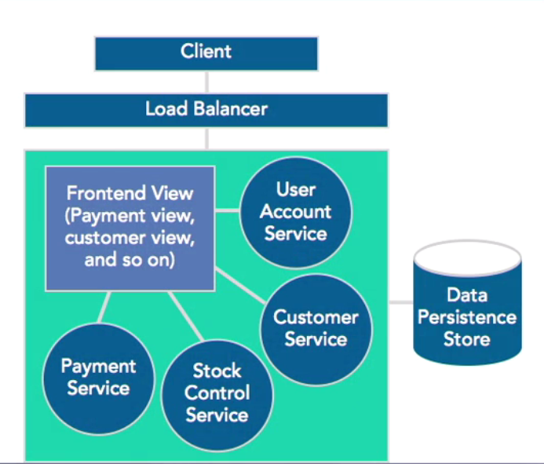

All the component are developed and packaged into one monolithic web application. It is then deployed in on monolithic Application. It is a very simple to develop and deploy an application and then to test it. If application might become large it will take time to the new team members to understand and then start working on it.

It is also difficult to change the technology in the future or it is nearly impossible to do so (Rewriting the whole application is almost never a affordable option).

It is not Scalabel.